Project module & api design

By: Justin Montgomery, Joe Tillett III, and Ethan Wauls

IST 412: The Engineering of Complex Software Systems

Urjaswala Vora, Instructor

Package/Modular Structure

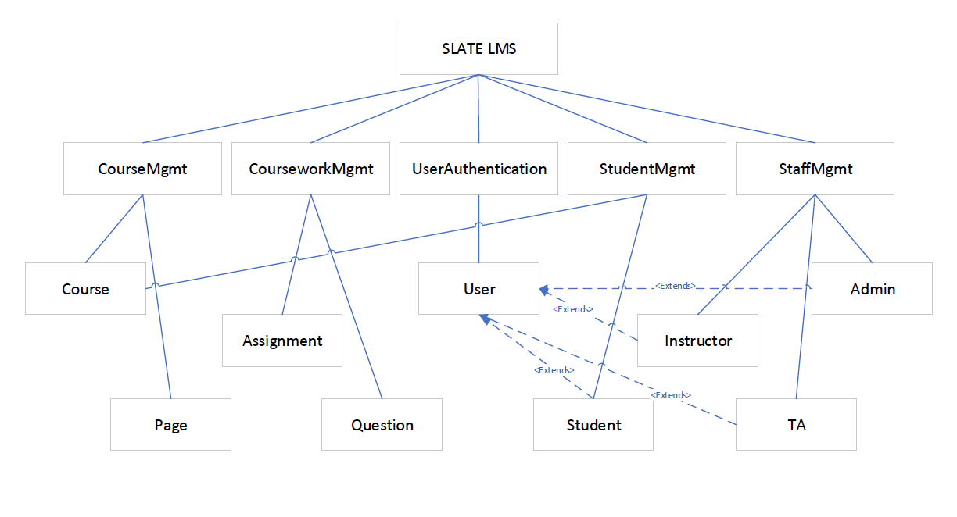

* First tier, “Slate LMS”, is the overall project.
* Second tier contains our five use cases/packages
* Third tier contains the Model Classes within our packages

Class Cohesion Assessment for Exposed Classes

|  |
| --- |
| **Class Student** |
|  |
| **LCOM4 - 1** |
| **Semantic Statement**  getEnrolledCourses and registerCourse rely on the enrolledCourses attribute |
| **Good** |

|  |
| --- |
| **Class Course** |
|  |
| **LCOM4 - 1** |
| **Semantic Statement**  addPage reliant on both courseID and coursePages attributes |
| **Good** |

|  |
| --- |
| **Class User** |
|  |
| **LCOM4 - 1** |
| **Semantic Statement**  changePassword, verifyUser, and getUserName methods rely on the username attribute |
| **Good** |

|  |
| --- |
| **Class Assignment** |
|  |
| **LCOM4 - 1** |
| **Semantic Statement**   Both get methods are reliant on the ArrayList<Question>, while the set methods are reliant on their respective Score attributes. In addition, each get method is also dependent on the respective set methods. |
| **Good** |